**Test Case 0007**

**System:** Bench

**Description:** Test to make sure that the search results are correct.

**Severity:** 3

**Instructions**

**Test 1**

1. Start the Bench application.
2. Click the button “Login” on the navigation bar.
3. Enter the email “team23project@gmail.com” into the text field labeled “Email address”.
4. Enter the password “12345678” into the field labeled “Password”.
5. Click the button “Login” below the field.
6. After the screen has loaded, click the button “Search” on the navigation bar.

**Expected Result:** The user should be directed to a “Search” page with a text input field as a search bar.

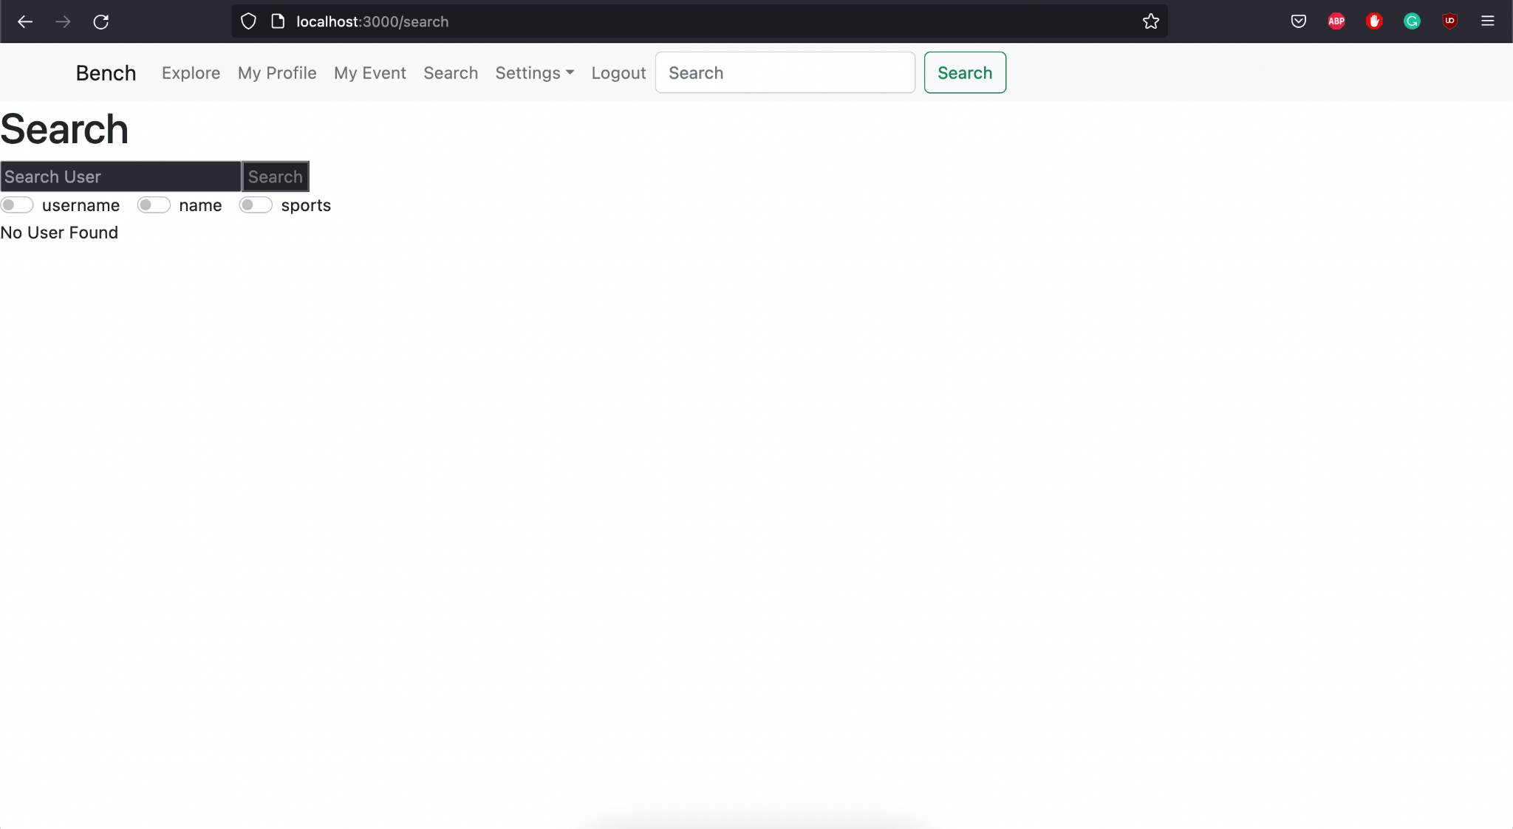

**Test 2**

1. Start the Bench application.
2. Click the button “Login” on the navigation bar.
3. Enter the email “team23project@gmail.com” into the text field labeled “Email address”.
4. Enter the password “12345678” into the field labeled “Password”.
5. Click the button “Login” below the field.
6. After the screen has loaded, click the button “Search” on the navigation bar.
7. Click the checkbox labeled “username”.
8. Enter any existing username such as “estelle” into the search bar.
9. Click the button “Search”.
10. Observe the center of the page.

**Expected Result:** One user profile panel should appear on the center of the page. This user should have the username matched with the text that was entered into the search bar.

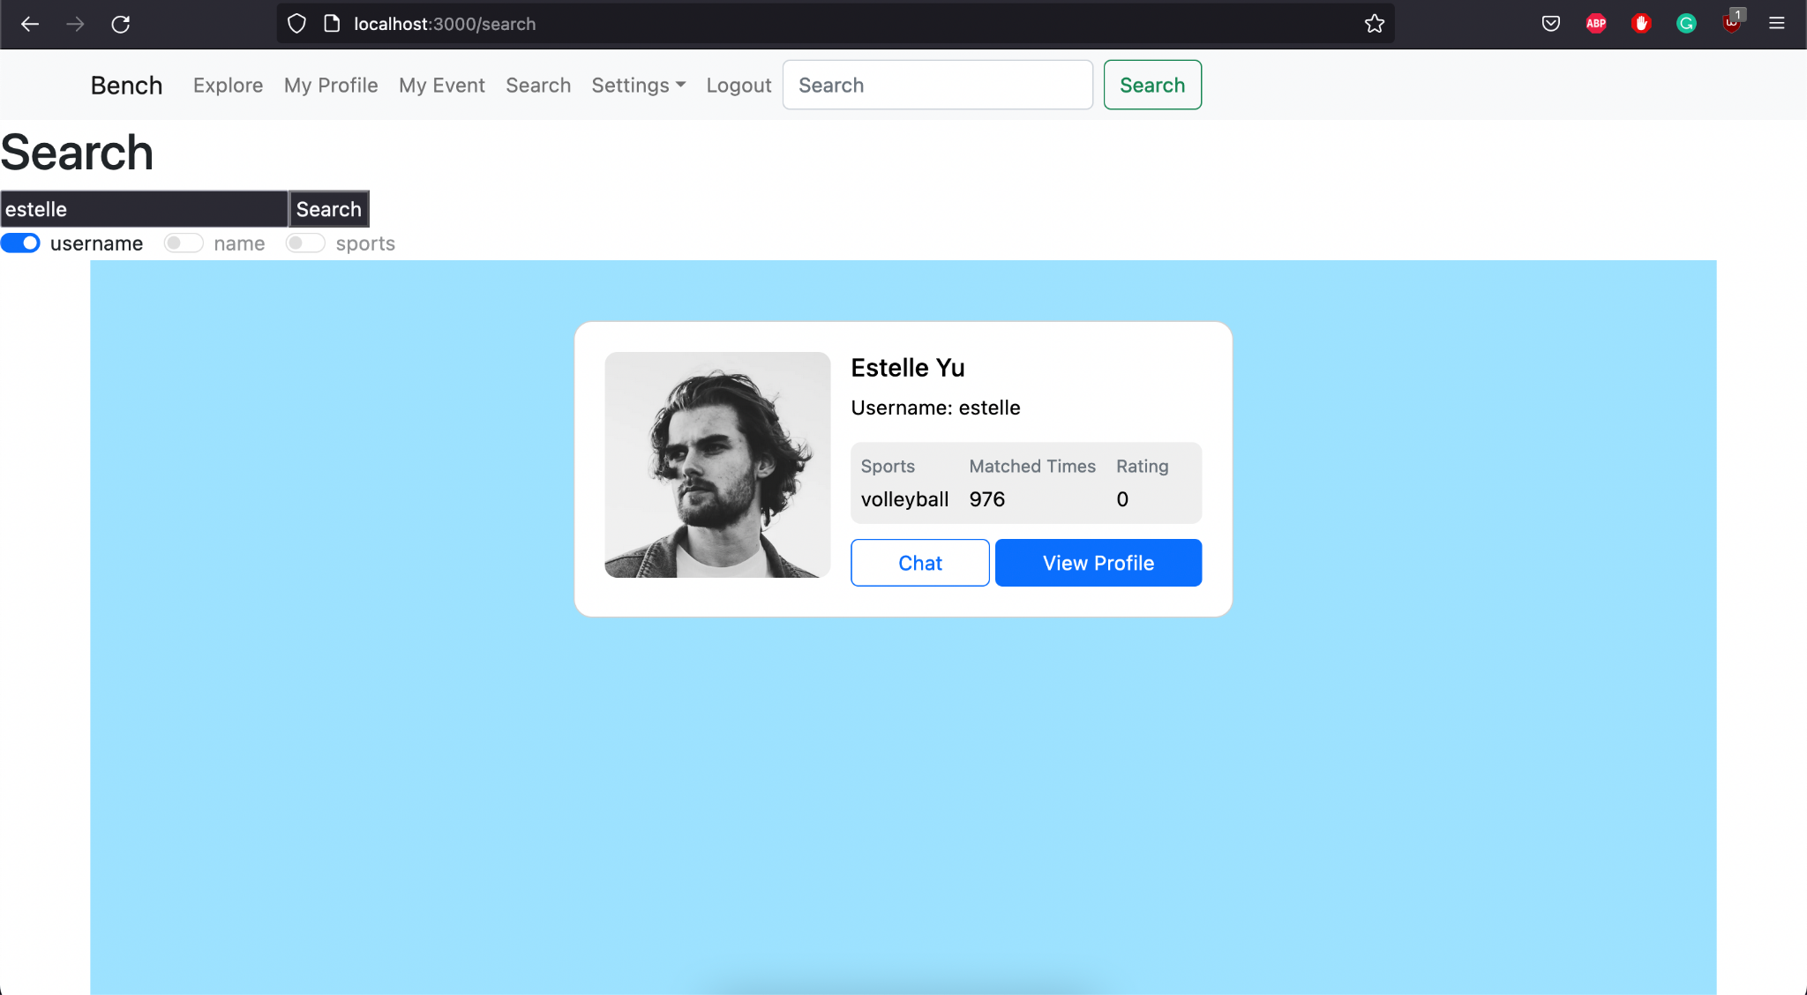

**Test 3**

1. Start the Bench application.
2. Click the button “Login” on the navigation bar.
3. Enter the email “team23project@gmail.com” into the text field labeled “Email address”.
4. Enter the password “12345678” into the field labeled “Password”.
5. Click the button “Login” below the field.
6. After the screen has loaded, click the button “Search” on the navigation bar.
7. Click the checkbox labeled “name”.
8. Enter any existing user’s name such as “Estelle Yu” into the search bar.
9. Click the button “Search”.
10. Observe the center of the page.

**Expected Result:** One or more user profile panel(s) should appear on the center of the page. These users should all have their names matched with the text that was entered into the search bar.

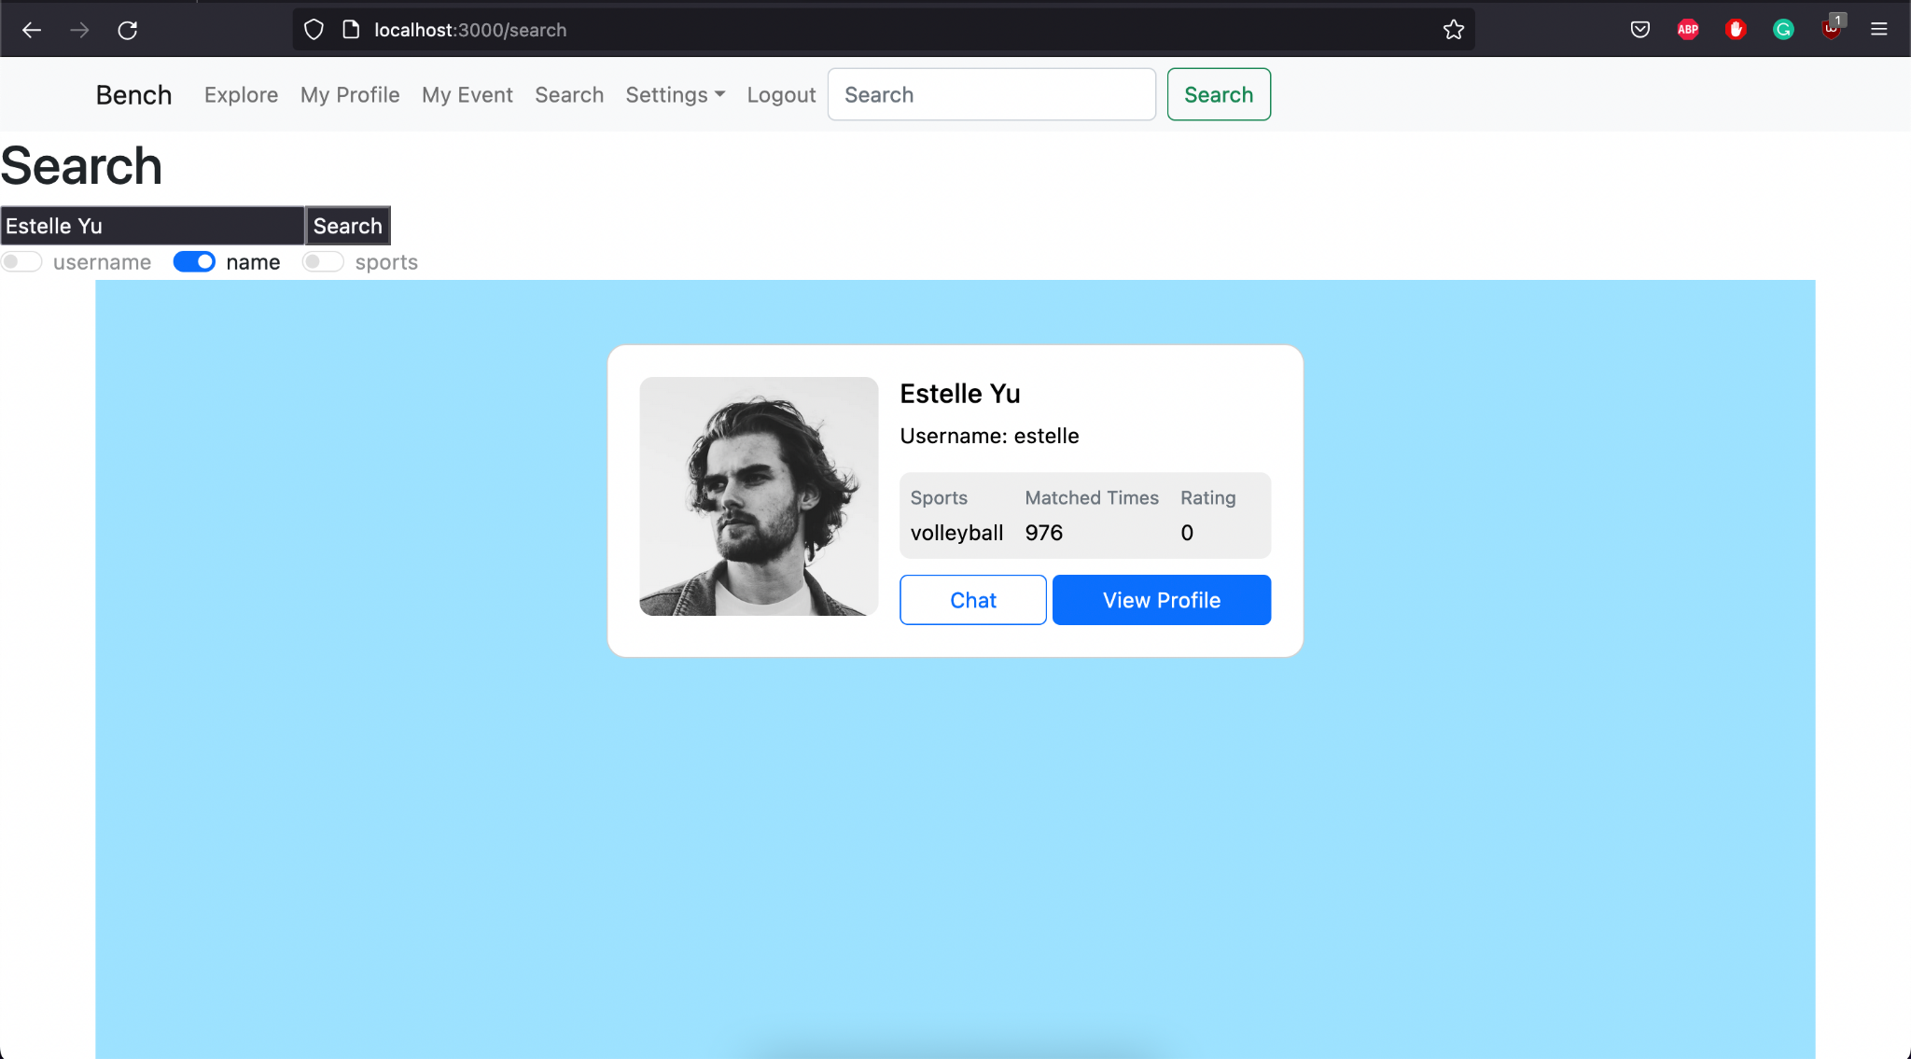

**Test 4**

1. Start the Bench application.
2. Click the button “Login” on the navigation bar.
3. Enter the email “team23project@gmail.com” into the text field labeled “Email address”.
4. Enter the password “12345678” into the field labeled “Password”.
5. Click the button “Login” below the field.
6. After the screen has loaded, click the button “Search” on the navigation bar.
7. Click the checkbox labeled “sport”.
8. Enter any sport such as “any” into the search bar.
9. Click the button “Search”.
10. Observe the center of the page.

**Expected Result:** One or more user profile panel(s) should appear on the center of the page. These users should all have their favorite sports field matched with the text that was entered into the search bar.

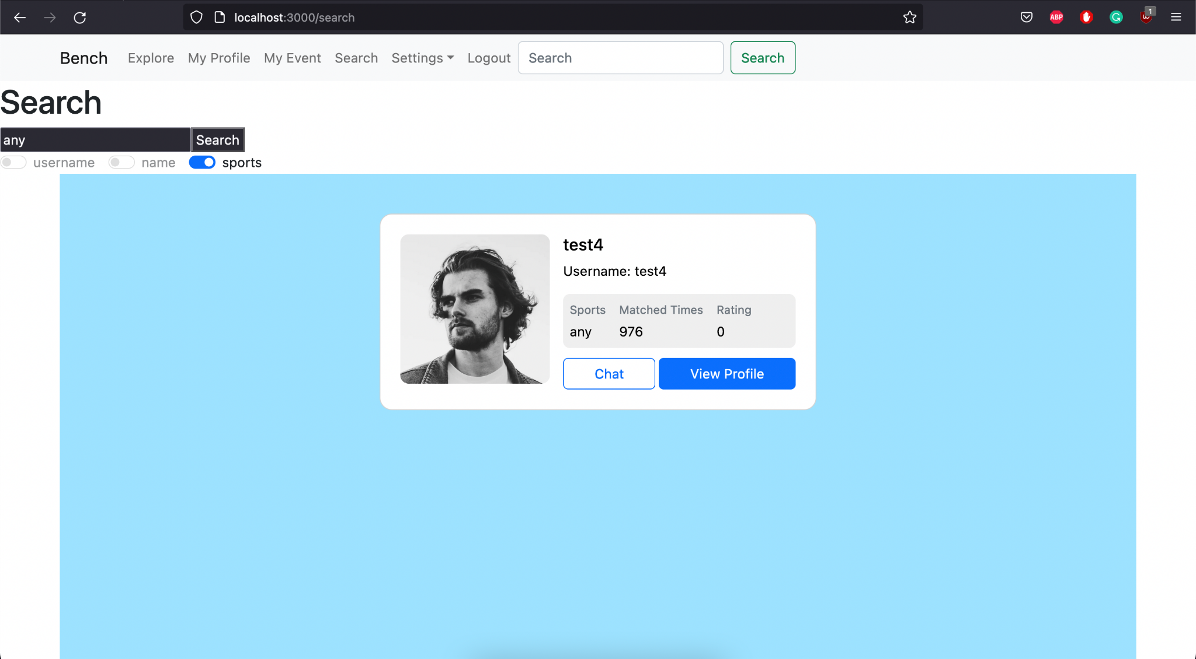

**Test 5**

1. Start the Bench application.
2. Click the button “Login” on the navigation bar.
3. Enter the email “team23project@gmail.com” into the text field labeled “Email address”.
4. Enter the password “12345678” into the field labeled “Password”.
5. Click the button “Login” below the field.
6. After the screen has loaded, click the button “Search” on the navigation bar.
7. Click any of the 3 checkboxes below the search bar.
8. Enter any value that matches with no user in the database into the search bar.
9. Click the button “Search”.

**Expected Result:** There should appear a line of text “No user found” below the search bar. The center of the page should be empty.

